Advance java experiment no.10

AIM: Write a simple JSP page to display a simple message (It may be a simple html page).

--------------------------------------------------------------------------------------------------------------------------

Program:

<%@ page language="java" contentType="text/html; charset=UTF-8" pageEncoding="UTF-8" %>

<!DOCTYPE html>

<html>

<head>

<title>Simple JSP Page</title>

</head>

<body>

<h1>Welcome to My JSP Page!</h1>

<p>This is a simple JSP page displaying a message.</p>

</body>

</html>

Explanation of the JSP Page:

1. **JSP Directive (<%@ page ... %>)**

<%@ page language="java" contentType="text/html; charset=UTF-8"

pageEncoding="UTF-8" %>

* + **language="java"** → Specifies that the page uses Java.
  + **contentType="text/html; charset=UTF-8"** → Ensures that the response is HTML and uses UTF-8 encoding.
  + **pageEncoding="UTF-8"** → Sets the encoding of the page to UTF-8 to handle special characters correctly.

1. **HTML Structure**

<!DOCTYPE html>

<html>

<head>

<title>Simple JSP Page</title>

</head>

<body>

<h1>Welcome to My JSP Page!</h1>

<p>This is a simple JSP page displaying a message.</p>

</body>

</html>

* + This is standard HTML, meaning when the JSP page runs, it simply renders as an HTML page in the browser.

**How to Run the JSP Page:**

**Step 1: Install Apache Tomcat**

JSP requires a servlet container like **Apache Tomcat**.

1. Download [Apache Tomcat](https://tomcat.apache.org/download-90.cgi) (choose the latest stable version).
2. Extract it to a folder (e.g., C:\tomcat\ or /opt/tomcat/ on Linux).
3. Set the **JAVA_HOME** environment variable to point to your JDK installation.

[take referecnce to output of experiment no.7 for set up of tom cat.]

**Step 2: Create a JSP File**

Navigate to the **webapps** folder in your Tomcat installation directory.

C:\tomcat\webapps\ROOT\

Create a file named [ example index.jsp] inside this folder.

Copy and paste the JSP code into index.jsp.

**Step 3: Start Tomcat**

* Go to the **Tomcat bin** directory:

cd C:\tomcat\bin

* Start Tomcat:

Run startup.bat

**Step 4: Open JSP Page in Browser**

* Open your browser and go to:

http://localhost:8080/index.jsp

* You should see the message displayed!

Output:

Starting tomcat:-

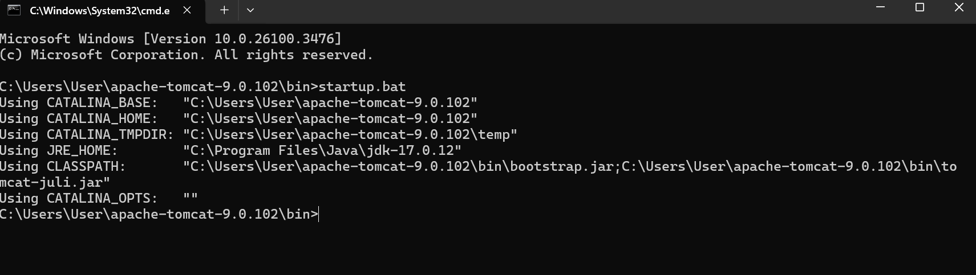

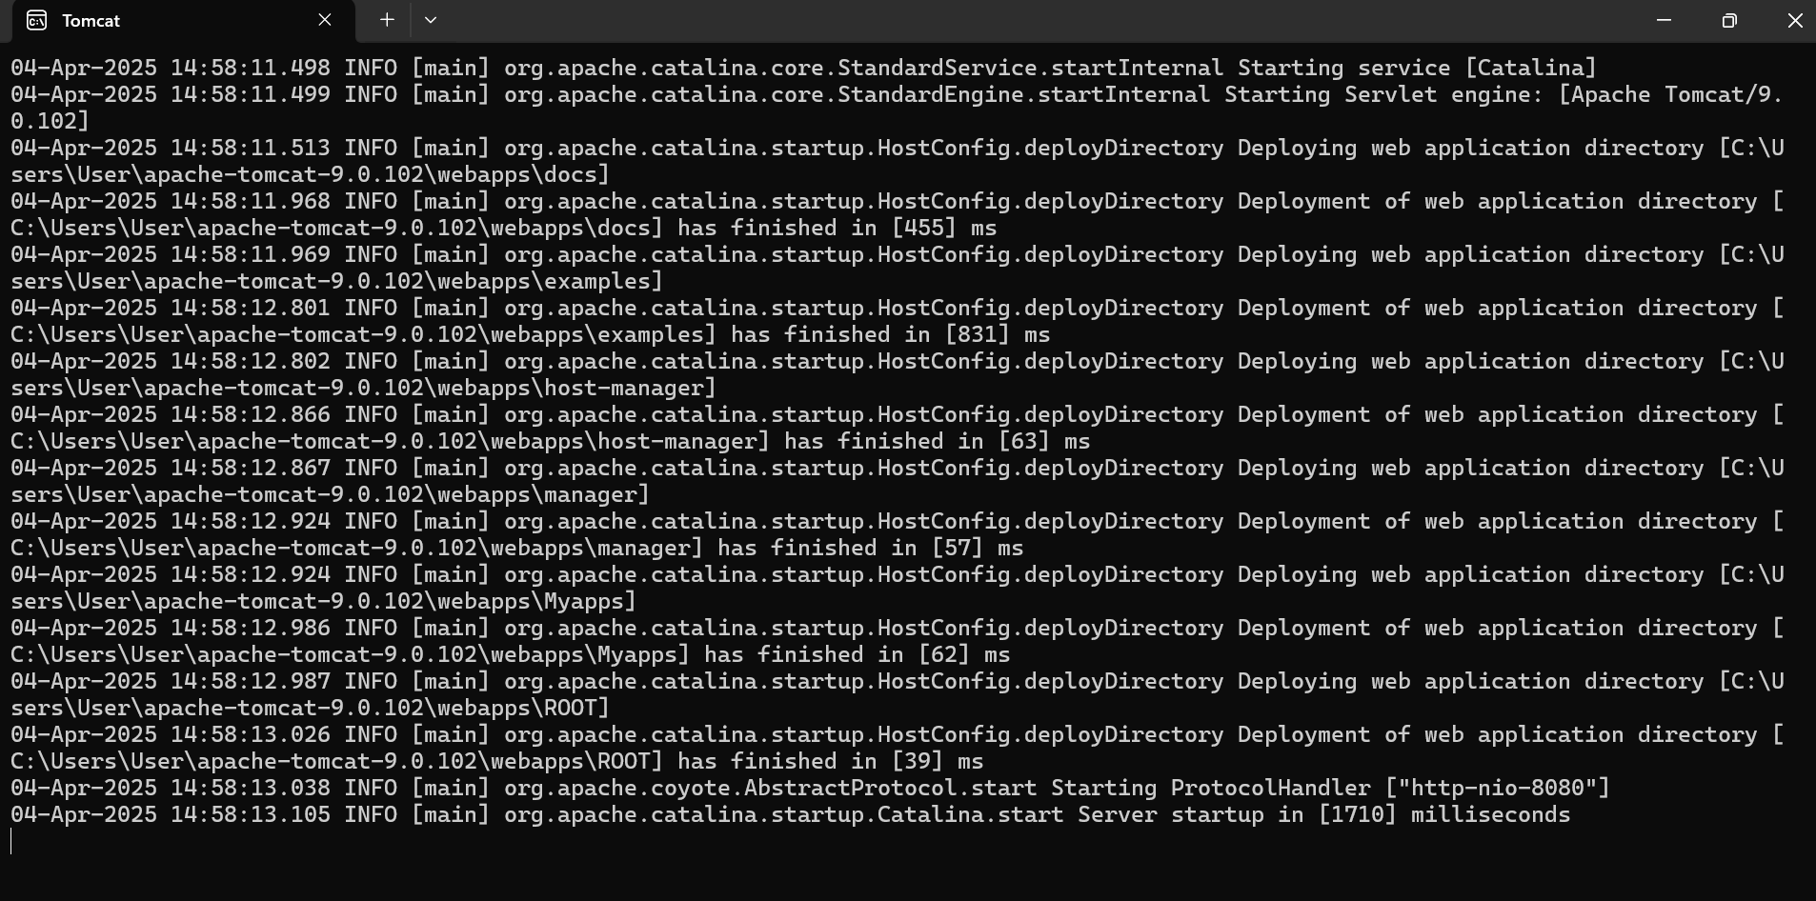

Displaying message on browser:

